|  |
| --- |
| **JDN Standards – Dell R430** |

Introduction 1

User & password guidelines 2

Standard configurations 2

Dell R430 server configuration 4

Installation preparation 7

VMWare Essentials Plus 5.5 installation 8

VMWare vCenter appliance 8

Template/OVA deployment 11

DC deployment 12

VM deployment 12

ISO deployment 13

Manual deployment of additional VMs 13

Automatic start/shutdown of VMs 14

Synology NAS configuration 15

UPS configuration 15

Veeam backup configuration 16

Notices and markings 16

# Introduction

This document describes the technical setup of the standards as defined for JDN deployments in 2015. This document is specific to JDN ships & remote sites and should not be seen as relevant for THVs or headoffices.

This document focuses on the Dell PowerEdge R430 solution used for the small-sized deployments (as described in the [deployment guidelines](http://meso.jandenul.com/meso-webtop/drl/objectId/090236ed82ce5e79)) and only takes a brief look at the network, NAS & UPS configuration.

The small deployment can be used for small offices, but can also be sent in a 19” rack shipping case to workshops and the like.

# User & password guidelines

The “**root**”, “**administrator**” & “**admin**” user accounts & passwords are reserved for installation and SA/SE usage. Which of the three user names is used can depend on the system in question. They should never be communicated to the crew (even the Captain).

A separate “**adl_tse**” user (with the same user rights) will be created for TSE usage. This will enable TSE to always use the same login on all devices. Ideally, TSE should never use the “root”, “administrator” & “admin” passwords after the installation has been concluded and the normal support cycle has started.

A separate “**adl_local**” user will be created to be communicated to the Captain (and potentially ELEC). Depending on the device in question, only restricted rights will be granted to the adl_local user.

Passwords chosen will be different for each ship or site, and as such should be diligently registered in RDM for each ship or site.

# Standard configurations

The standard configuration for ***small*** ***vessels*** consists of:

* Server:
  + Dell R430
    - two Xeon CPUs
    - 96GB RAM
    - Eight 1.2TB 10k SAS 2.5” disks
    - PERC H730
    - Redundant PSUs
    - iDRAC Enterprise
* Networking:
  + Firewall:
    - Single SRX240
  + Switches:
    - Redundant Juniper EX3300 (48 port)
* Backup storage:
  + Single Synology RS815+ (4x4TB) or Synology DS1515+ (5x4TB)

The standard configuration for ***small offices & workshops*** consists of:

* Server:
  + Dell R430
    - two Xeon CPUs
    - 96GB RAM
    - Eight 1.2TB 10k SAS 2.5” disks
    - PERC H730
    - Redundant PSUs
    - iDRAC Enterprise
    - Dell **Sliding** ReadyRails
* Networking:
  + Firewall:
    - Single SRX100H2
  + Switches:
    - Single Juniper EX3300 (48 port) or EX2200 (48 port). EX3300 are preferred, but can generate noise complaints in quiet office environments.
* Backup storage:
  + Single Synology RS815+ (4x4TB) or Synology DS1515+ (5x4TB)

The standard configuration for ***mobile/temporary******offices & workshops*** consists of:

* Server:
  + Dell R430
    - two Xeon CPUs
    - 96GB RAM
    - Eight 1.2TB 10k SAS 2.5” disks
    - PERC H730
    - Redundant PSUs
    - iDRAC Enterprise
* Networking:
  + Firewall:
    - Single SRX100H2
  + Switches:
    - Single Juniper EX3300 (48 port) or EX2200 (48 port). EX3300 are preferred, but can generate noise complaints in quiet office environments.
* Backup storage:
  + Single Synology RS815+ (4x4TB)
* Special equipment:
  + Rack (travel case):
    - Amazon Rack AR0461-0712 Rack 4Ux610 (light grey)
  + Rack mounting:
    - Pulti rack mountable PDU (with a mix of euro/schuko & C13 sockets)
    - If a Digi WR44 4G modem is used, a Racksolutions.eu Sliding Computer Shelf 20" (1USHL-112-20). The WR44 & SRX will be attached to it. If only an SRX100H2 is required, a static SRX shelf/tray can be used instead.
    - Dell ReadyRails **Static** 2/4 post rack rails for R430 (Caution: These rails need to be modified to fit the rack, the rounded hole mount needs to be cut off (red part), optionally the green parts can be removed as well)

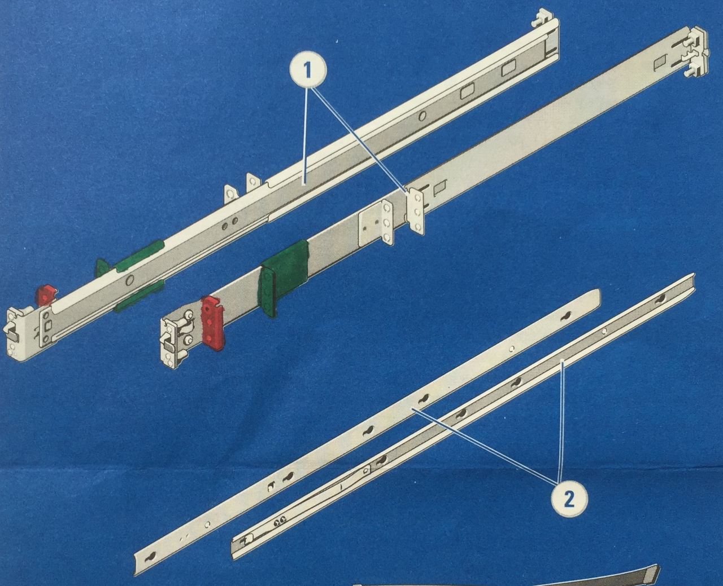

Consult the deployment guidelines for more information:

<http://meso.jandenul.com/meso-webtop/drl/objectId/090236ed824d5fa5>

# Dell R430 server configuration

Power on the server.

Press F2 when prompted to enter system setup.

Enter System BIOS.

Go to System BIOS Settings > Boot Settings

* Select Boot Mode BIOS

Go to System BIOS Settings > Boot Settings > BIOS Boot Settings

* Disable the NIC as boot option (prevents waits for PXE boot)

Go to System BIOS Settings > System Profile Settings

* Select Performance profile

Enter iDRAC Settings

Go to iDRAC Settings > Network

* Under Network Settings:
  + Enable NIC
  + NIC Selection dedicated
  + Auto negotiation on
* Under Common Settings:
  + Fill out the DNS DRAC Name (i.e. <prefix>-iDRAC01)
  + Fill out the DNS Domain Name (i.e. <prefix>.situs)
* Under IPv4 Settings:
  + Enable IPv4
  + Disable DHCP
  + Configure Static IP Address (.250)
  + Configure Static Gateway (.1)
  + Configure Subnet Mask (255.255.255.0)
  + Configure Static Preferred DNS Server (.11)
  + Configure Static Alternate DNS Server (8.8.8.8)
* Under IPv6 Settings:
  + Disable IPv6
* Under VLAN Settings:
  + Disable VLAN ID
  + Apply your changes

Enter Device Settings

Go to Device Settings > Integrated Raid Controller (PERC H730 Mini)

Go to Main Menu > Configuration Management

* If virtual disks already exist in the system, clear their configuration
* Then select Create Virtual Disk
* Select RAID level 6
* Select Physical Disks From Unconfigured Capacity
* Press Select Physical Disks
* Select the checkboxes next to all disks, then press Apply Changes
* Create the following virtual disks, VirtualDisk1R6 with capacity 1.5TB using the default settings except for Full Initialization
* Using the Free capacity, then create VirtualDisk2R6 (1.5TB), VirtualDisk3R6 (1.5TB) & VirtualDisk4R6 (remaining capacity ~2TB), both with Full Initilization

While the disks are initializing, log into the iDRAC (x.x.x.250)

Note: You will need to apply settings for each subsection of a page, or your changes will be lost!

Go to Overview > Server > Properties > Details

* Set Data Center Name (site or shipname).
* Aisle, rack or room name can contain additional information related to the rack's location.

Go to Overview > Power / Thermal > Power Configuration > Power Configuration

* Under Power Supply Options, select Input Power Redundant.

Go to Overview > Alerts > Alerts

* Select Enabled to enable alerts.
* Enable email alerts for critical system health, storage & configuration

Go to Overview > Alerts > SNMP and Email Settings

* Set SNMP Community String to SNMP-RO
* Set SNMP Trap Format to SNMP v2
* Set Destination Email Addresses (+ state enabled)
* Configure a mail server:
  + For deployments without a commbox enter:
    - SMTP server: smtp.jandenul.com
    - Source email address: <hostname>@jandenul.com (example: ARP-IDRAC01@jandenul.com)
    - Note: this user/address will need to be created and the IP needs to be whitelisted by SA.
  + For deployments with a commbox enter:
    - SMTP server: <admin_trust-range>.17
    - Source email address: <hostname>@<prefix>.jandenul.com (example: [PRO-IDRAC01@pro.jandenul.com](mailto:PRO-IDRAC01@pro.jandenul.com))

**Note**: to send the test mail, make sure to click 'Apply' first, as the iDRAC will use the previous/empty settings if you don't.

Go to Overview > Alerts > Alert Recurrence

* Set 7 days as Warning recurrence.
* Set 1 day as Critical recurrence.

Go to Overview > iDRAC Settings > Properties > Settings

* Select Time Zone Etc/UTC in case of a ship or the local time zone if used on shore, and press Apply. Mobile setups with unknown destinations are set to UTC.
* Select Enable NTP, enter NTP servers “172.16.3.22” (if a time server is present locally), “10.128.1.72” & “NTP1.oma.be” and press Apply.

Go to Overview > iDRAC Settings > User Authentication > Local Users

* Configure additional users:
  + adl_tse with administrator privileges (IPMI & iDRAC).
  + adl_local with operator privileges (IPMI & iDRAC).
* Make sure both new users are enabled & have passwords set.

Go to Overview > Hardware > Front Panel

* Under LCD Settings:
  + Set Home Message User Defined: <prefix>-ESX01 JDN-<number>

Firmware:

Go to Overview > Server > Properties > System Inventory, scroll down to Firmware Inventory and verify that the latest supported drivers are used. If not, apply the latest firmware.

# Installation preparation

Installation has been largely automated to speed up deployments. The scripts are written under the assumption that they will be executed on a clean environment.

The installation steps below require some preparation:

* The necessary files can be found at \\jdn-file01\Ict_New_Standard_Sites_Vessels and should be copied locally to F:\Standaarden\... for easy access (assuming F:\ is your external disk or your data partition). The “deprecated” folders can be ignored, however if you are going “on site” for your installation it can be wise to include them as well in case of issues with the current files. **The folder structure should be maintained as is, since the provided scripts have references to files and folders relative to their position.** Make sure the user which is executing the scripts has rights to access the copied folders.
* To be able to execute the provided scripts, a few programs should be installed on your computer. Ideally these will be included as default software for TSE, but in the meanwhile install these manually:
  + VMware ovftool 4.0 or higher.
  + Powershell 3.0 or higher.
  + PowerCLI 6.0 or higher.
* During the installation of PowerCLI, you will be prompted to allow execution of scripts by setting Set-ExecutionPolicy. Make sure Powershell Execution Policy is set correctly, as none of the scripts will work without this.
* If the scripts pop up strange errors, first troubleshoot by executing:  
  *Add-PSSnapIn VMware.VimAutomation.Core*
* Since a bootable USB stick must be created, you will need a program to do this. The default JDN software for this is Rufus and this should already be installed on all TSE laptops. Unetbootin is included as well to have an alternative.

Modify your locally copied scripts:

* Under ...\Scripted Install\ESXi install stick\Dell R430\ksscripts\ edit the .cfg files in accordance with the comments present within the file.
  + Or, use the script from the 'Generate_ESX_Config' folder.

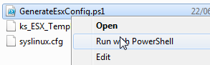

Just follow the steps in the script and fill in the requested values according to your setup (see items in green in the screenshot)

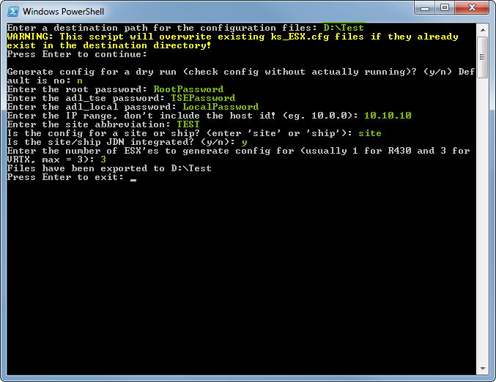

The necessary config files will be generated.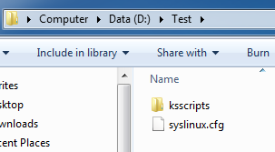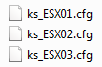

* Under ...\Scripted Install\Scripts\ edit the variables in each of the 4 scripts which are prefixed with a number in accordance with the comments present within the file. Do not edit the .txt or StartThisElevated files.

Bootable USB stick preparation:

* Use Rufus or Unetbootin to create a bootable USB stick from the dell customized ESXi ISO file. These should be located under ...\Software\Current\Virtualization\
* Copy the files from ...\Scripted Install\ESXi install stick\Dell R430\ into the root directory of your newly created USB stick.
* Go to the ksscripts folder on your USB stick and edit the .cfg files in accordance with the comments present within the file or replace the files with the ones generated by the script if you used this method.

# VMWare Essentials Plus 5.5 installation

In this section we install VMWare ESXi 5.5 on the server’s local storage (8 SAS disks in Raid 6), using an ESXi Dell customized image. (If you use the standard non-custom installer, you will need to add the Dell drivers manually.)

The USB stick used to install ESXi can contain a large part of the required configuration in a so-called “kickstart” script. These kickstart scripts will need to be modified to fit your specific environment.

Installing ESXi:

* During booting of the server verify that the local raid controller of the server has 3 virtual disk assigned. The first available disk will be used for the local install.
* Plug the USB stick into the server, enter the boot menu and select the USB stick as boot source in the BIOS. It is recommended to use BIOS, not UEFI.
* If you booted from BIOS, you will see a boot menu showing multiple options. This will not occur if you chose UEFI. The boot menu will include the configured .cfg file included on the USB stick.
* Once an option has been selected, the installer will kick off the install. During the install, the server will need to reboot. Do not remove the USB after this reboot. It is still needed to complete the configuration after reboot.
* Once the configuration has been completed, the server will display the ESXi’s Direct Console User Interface (DCUI). Log in by pressing F2 and entering the username (root?) and password as configured in your kickstart configuration files. Verify that your configuration was correctly applied.
* After the ESXi has been installed, connect to the server using the vSphere client. Go to storage and rename the local storage to “VirtualDisk1R6”.
* Then “Add Storage” and select the 1.5TB disk and name it VirtualDisk2R6.
* Then “Add Storage” and select the 1.5TB disk and name it VirtualDisk3R6.
* Then “Add Storage” and select the 2TB disk and name it VirtualDisk4R6.

# VMWare vCenter appliance

In this section we deploy the VMWare vCenter appliance ova/ovf template to the first datatstore on the server. The configuration is largely automated, but some steps cannot be scripted in version 5.5.

Once networking is set up, the appliance management interface can be accessed by surfing to its IP using https & port 5480. The settings in this interface will most likely not need to be changed. Most configuration will be done through the vSphere Web Client: https://<vCenterIP>:9443/vsphere-client/

Step by step deployment procedure:

* Execute your local copy of ...\Scripted Install\Scripts\StartThisElevated.ps1 while elevating the script (run PowerCLI as administrator).
* You will be shown a numbered menu and an overview of the currently configured variables which will be used for the install.
* Pick the “*Deploy vCenter*” menu option and press enter.
* The vCenter appliance will be deployed using your previously edited configuration. This will include adding the configured ESX server into a cluster, although there is only one server available. This is done for management reasons, as vCenter offers a web interface and is required for some tools & utilities.
* Verify that the ESXi server has been added to the cluster by logging into the vCenter’s vSphere Web Client. For this, use the [administrator@vsphere.local](mailto:administrator@vsphere.local) user, since you will need the SSO administrator for steps further down. The root user does not have rights to see or modify SSO groups.
* Back in the vSphere (Web) client, configure the Single Sign-On policies:
  + Go back to the home page of the vSphere Web Client. Click “Administration” on the menu bar.
  + Under “Administration” > “Single Sign-On” > “Configuration”, click tab “Policies” and then “Password Policies” & Edit. Configure:
    - Description: “JDN policy”
    - Maximum lifetime: 9999 days
    - Restrict re-use: 1 passwords
    - Maximum length: 20
    - Minimum length: 10
    - Characters: At least 2 alphabetic, 1 numeric, 1 lower case, 1 upper case.
  + Now click “Lockout Policy” & Edit. Configure:
    - Description: “JDN Policy”
    - Max failed attempts: 10
    - Time interval between failures: 10 minutes
    - Unlock time: 10 minutes
* Configure the Single Sign-On domain:
  + Under “Administration” > “Single Sign-On” > “Configuration”, click tab “Identity Sources”.
  + Select the line with “vsphere.local”.
  + Click “Set as Default Domain”.
  + This will allow “[administrator@vsphere.local](mailto:administrator@vsphere.local)” to log in as “administrator” instead. This also makes it easier for users which we will create in the vsphere.local SSO domain. However, the “root” account will now need to log in with “root@localos”.
* Virtual machine power user
  + Create a new Access Control role:
    - Under Administration > Access Control > Roles, select the line with “Virtual machine power user (sample)”.
    - With the line selected, click the “Clone role action” icon.
    - Name the new role “Virtual machine power user”.
    - Right click the new role and click “Edit”.
    - Under “Host” > “Configuration”, check the checkboxes for “Maintenance” & “Power”.
    - Press “OK”.
* Configure the Single Sign-On users:
  + Under “Administration” > “Single Sign-On” > “Users and Groups”, click tab “Users”.
  + Make sure Domain “vsphere.local” is selected.
  + Click the + sign to create a local user:
    - User name: adl_local
    - First name: ADL
    - Last name: Local
  + Click the + sign to create a TSE user:
    - User name: adl_tse
    - First name: ADL
    - Last name: TSE
  + Click the + sign to create a backup service user:
    - User name: srv_backup
    - First name: Service User
    - Last name: Backup
  + Click the + sign to create a backup service user:
    - User name: srv_ups
    - First name: Powerchute
    - Last name: UPS
  + Click the “Groups” tab.
  + Select the “Administrators” group.
  + In the “Group Members” pane, click the + sign to add users to the group.
  + Add “adl_tse”, “srv_backup” & “srv_ups” users and click OK.
* Assign Permissions:
  + Go to the vCenter server, select the “Manage” tab and then the “Permissions” button.

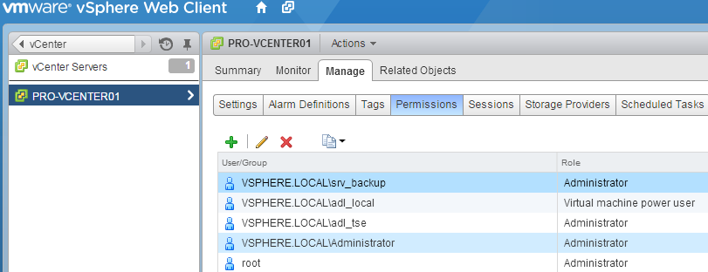

* + Click the + sign to add a user.
    - Click “Add...” under the “Users and Groups” section and enter:
      * Domain: VSPHERE.LOCAL
      * User/Group: adl_local
      * Click “Add”.
      * Click “OK”.
    - Select “Virtual machine power user” from the drop down under “Assigned Role”. Make sure NOT to select the “sample” role.
    - Click “OK”.
  + Click the + sign to add a user.
    - Click “Add...” under the “Users and Groups” section and enter:
      * Domain: VSPHERE.LOCAL
      * User/Group: adl_tse, srv_backup & srv_ups
      * Click “Add”.
      * Click “OK”.
    - Select “Administrator” from the drop down under “Assigned Role”.
    - Click “OK”.
  + Change the vCenter retention policy.
    - Go to the vCenter server, select the “Manage” tab and then the “Settings” button and “Edit”
    - At the database settings
      * Check “Task cleanup” and set task retention to “90”
      * Check the “Event cleanup” and set the event retention to “90”

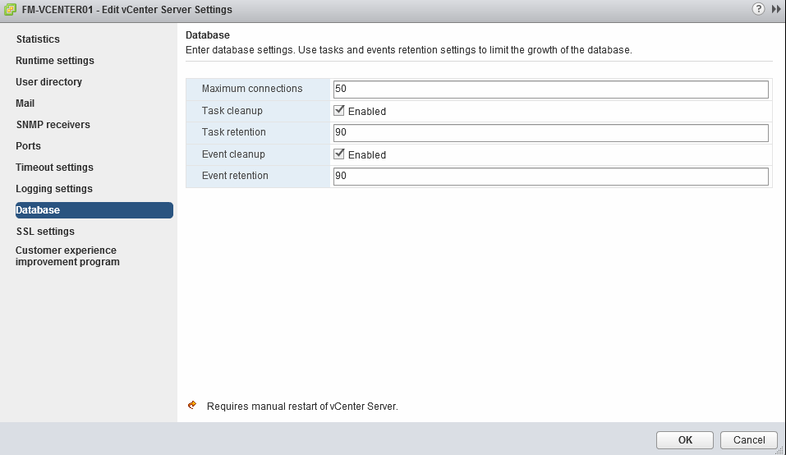

# Template/OVA deployment

In this section we deploy the OVAs which were present on the network share and convert them into ready to use templates.

Step by step deployment procedure:

* If you do not have the script already running, execute your local copy of ...\Scripted Install\Scripts\StartThisElevated.ps1 while elevating the script (run PowerCLI as administrator).
* You will be shown a numbered menu and an overview of the currently configured variables which will be used for the install.
* Pick the “*Deploy OVAs*” menu option and press enter.
* The OVAs will be deployed and subsequently converted to templates.
* Verify that the necessary templates were made available.

# DC deployment

In this section we deploy the domain controller OVA and configure the domain.

Step by step deployment procedure:

* If you do not have the script already running, execute your local copy of ...\Scripted Install\Scripts\StartThisElevated.ps1 while elevating the script (run PowerCLI as administrator).
* You will be shown a numbered menu and an overview of the currently configured variables which will be used for the install.
* Pick the “*Deploy Domain Controller*” menu option and press enter.
* The DC OVA will be deployed.
* The VM contains a number of configuration scripts that can be run to configure the domain automatically. However, you should always retrieve the latest DC configuration scripts from Meso. Consult the other documentation to learn more about the DC configuration steps and do not forget to execute them before continuing.
* Note: Be sure to wait long enough before executing the install & configure scripts. Your VM needs to reboot to run the customization script which is deployed together with your VM.

For detailed description of DC configuration, please consult <http://meso.jandenul.com/meso-webtop/drl/objectId/090236ed825acff1>

More information on the XML structure for creating shares etc can be found in <http://meso.jandenul.com/meso-webtop/drl/objectId/090236ed825a7474>

# VM deployment

In this section we deploy a number of VMs, put them in the right folders and where possible join them to the available domain.

Step by step deployment procedure:

* If you do not have the script already running, execute your local copy of ...\Scripted Install\Scripts\StartThisElevated.ps1 while elevating the script (run PowerCLI as administrator).
* You will be shown a numbered menu and an overview of the currently configured variables which will be used for the install.
* Pick the “*Deploy VMs*” menu option and press enter.
* VMs will now be deployed & started. Keep in mind that joining them into the domain (if available) can take up to 15 minutes after deployment. To join the domain, they will restart automatically. Please do not interrupt their configuration until they have joined the domain (if applicable).
* After the script has completed, you can begin manually deploying additional VMs as required by your specific environment.
* Once the VMs have joined the domain, do not forget to move them to the correct OUs in Active Directory and to enable time synchronization via the VM Tools (under “Edit VM Settings” > “VM Tools” > “VM Tools”) where applicable. Warning: The DC should NEVER synchronize time through VM Tools.
* Your MGMT01 VM will have 2 NICs, only one of which has an IP assigned. You can manually configure the second NIC as:
  + IP: 172.16.3.20
  + Mask: 255.255.255.128
  + Do not configure a gateway or DNS on this NIC
* Once all the VMs have joined the domain, now run the “Finalize Deployment” option of the PowerCLI script. This will set the time zone to UTC, as is standard for ships. For offices & sites, using UTC is allowed, but other time zones can be configured. To do this, modify the $timeZone variable in the $SETTIMEZONESCRIPT string. Be careful, “CET” is not a valid entry. You need to use the syntax found in tzutil.exe /l. Example: “CET” translates to “Romance Standard Time”.
* Currently Windows 7 client VMs are rolled out with only a 5 GB D:\ partition. It is allowed to extend this partition up to 20 GB for the captain, chief & elec VMs. Extending this partition should be avoided for all other VMs.

# ISO deployment

Go to the first shared datastore using your vSphere client or vSphere Web client. Create a new folder named “ISO”. Manually upload the useful ISOs available in ...\Software\Current\ to the datastore. It is especially important to upload the Windows ISOs.

# Manual deployment of additional VMs

Additional VMs can be deployed as documented in <http://meso.jandenul.com/meso-webtop/drl/objectId/090236ed81c55abc>

# Automatic start/shutdown of VMs

Now that all VMs have been deployed, we will configure them to automatically start when the server starts and automatically shut down when the server halts. This is a feature only available for standalone servers (which are thus not part of a high availability cluster).

The following steps can both be executed with the vSphere Client or with the vSphere Web Client (https://<vCenterIP>:9443/vsphere-client/).

Log in, go to the host overview & select the host in the left panel.

Go to “Configuration” (or “Settings” > “Manage”).

Select “Virtual Machine Startup/Shutdown”.

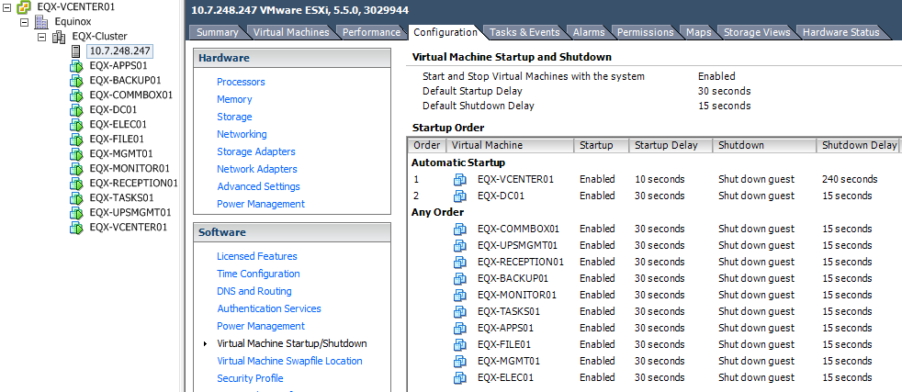

Press “Properties” (or “Edit”)

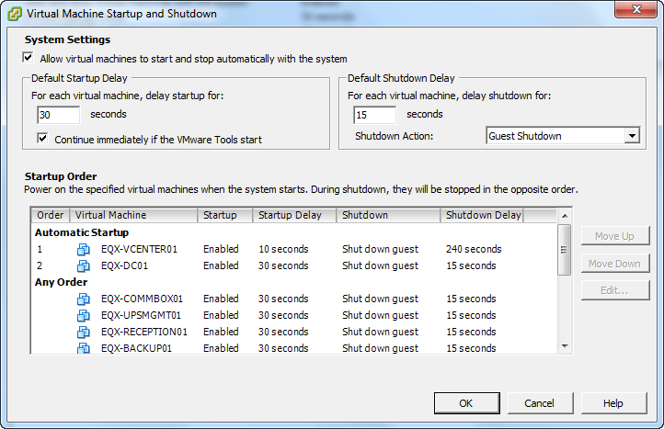

Set “Allow virtual machines to start and stop automatically with the system”.

Configure “Default Startup Delay” as 30 seconds and select “Continue immediately if the VMtools start”.

Configure “Default Shutdown Delay” as 15 seconds, with default shutdown action as “Guest Shutdown”.

Now order the VMs:

Automatic Startup:

1. vCenter,
2. DC.

Any Order:

* All other VMs.

Now select the vCenter and “Edit”. Manually configure the Startup Delay to be 10 seconds and the Shutdown Delay to be 240 seconds. All other VMs should use the defaults as set above.

# Synology NAS configuration

See: <http://meso.jandenul.com/meso-webtop/drl/objectId/090236ed81d46020>

Note that the Synology is standalone & is not mirrored/clustered with a spare Synology.

# UPS configuration

If applicable, see <http://meso.jandenul.com/meso-webtop/drl/objectId/090236ed81c55af7>

# Veeam backup configuration

See <http://meso.jandenul.com/meso-webtop/drl/objectId/090236ed81c55b22>

# Notices and markings

The setup should contain the following markings:

* JDN number tags:
  + The Amazon Rack case needs to be labelled with the JDN number on the inside of the case, on the front lip.
  + The R430 has a pull out tag on which the JDN number can be pasted. The JDN sticker will need to be trimmed to fit.
  + The SRX240 & Digi WR need to be labelled on top or rear.
  + The EX switch & Synology need to be labelled on the rear.
* Network cables:
  + All network cables should be labelled using the Altec label printer (wrap around, multiline labels) with both the function of the cable (or to where it connects) and on the next line the network port (e.g. EX x/x/x) to which they should be connected to.
* Case: The case should be marked (spray painted stencil or rugged sticker) with
  + “Fragile” and “This side up” on the left & right side.
  + “JDN logo” on the rear cover.